Student Management System
Technical Story Card

Revision History
Version No. | Date | Prepared by / Modified by | Significant Changes
1 | 24-02-2022 | Prakash | Introduction
2 | 24-02-2022 | Neethu Davis | Case model
3 | 24-02-2022 | Najula | Scope of Change
4 | 24-02-2022 | Harish | Flow Chart

Glossary
Abbreviation | Description
BSC | Business Story Card
TSC | Technical Story Card

Table of Contents
1 Introduction 3
2 Scope of Change 3
3 List of impacted modules 3
4 Design and Detailed technical updates 4
4.1 Process model 4
4.1.1 Use case Model 4
4.1.2 Sequence diagram 4
4.2 Proposed user Interface design 4
4.3 Database design changes 4
4.4 Refactoring related changes 4
4.5 Construction strategy and re-use 4
5 Details of Alternative Design Approach 4
6 Other Technical changes 5
6.1 Automation tasks / changes 5
6.2 CI / Build relates tasks / changes 5
6.3 Non-functional related changes 5
7 Additional details 5
7.1 Open Questions / clarifications / Assumptions 5
7.2 Additional notes to technical team 5
8 References 5

Introduction
This software application stores all the student's information in a database. It is an application developed in Java and the database used is SQL. It contains student information like student id, name and date of admission.
It is an easy-to-use application and has a user-friendly interface. It is totally built at the administrative end which means that only the admin has access rights to change or modify any records. So, this makes it a safe and reliable application to use.
The main aim of developing this application was to reduce the errors that occur in the manual system.
One can search the details easily by just entering a student id. In earlier systems, there was not such a facility to do so. All the details are stored in an SQL database. It is easy to update any student details. All the student records are integrated and so this makes it a user-friendly and easy to use application.

Scope of Change
Change will not be entertained and whatever specifications mentioned in this document is final.

List of impacted modules
All the functional modules will be created from scratch.

Design and Detailed technical updates

Process model

Use case Model

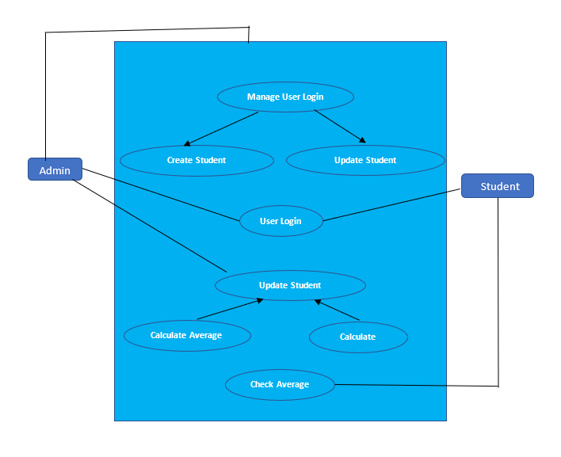

Brief Description | Login
Basic Flow | This use case describes how an Student gets into User Profile page  - The student has to register himself into the system.  - After the successful login, student will be taken to the appropriate landing page.  - The following information is required to login.  - Student ID  - Student Name  - Date of admission
Alternate Flow | - The system will validate the credentials provided. If credentials are invalid, login form will be redirected to create the profile
Validation | - Valid Student Name  - Valid Student ID  - Valid student date of admission
Pre-Conditions | Student should have network access and Browser with latest updates.
Post-Conditions | Student details page has to be displayed.

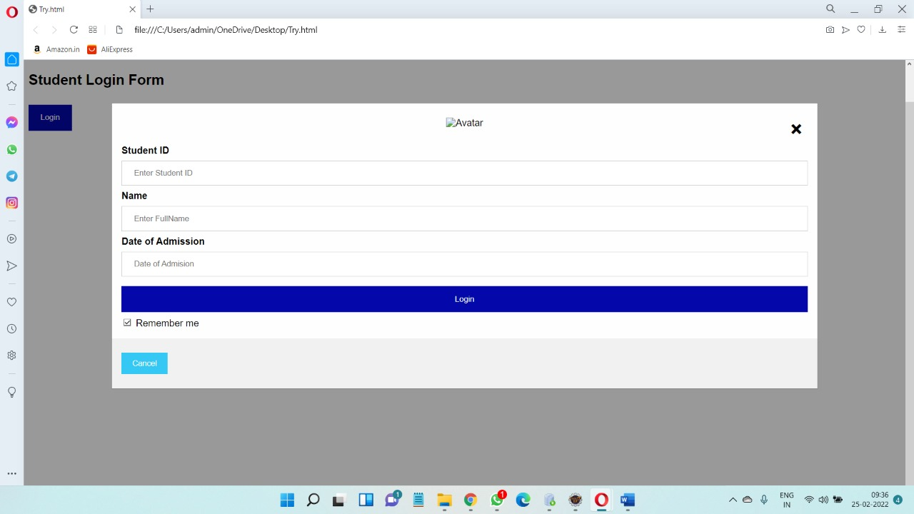

Brief Description | User Profile
Basic Flow | This use case describes how a student profile in to the system  - The student should enter the details in the form.  - After the successful submission, Details will be entered into the table  - The following information is required during registration.  - Student Name  - Student ID  - Student admission
Alternate Flow | - The system will validate the information provided. If any invalid data is found, the input form will be redirected with error message.
Validation | - Name is required and minimum 3 characters and max 30 characters.  - Student name can be alphanumeric.  - The Date of joining for admission.
Pre-Conditions | Student should have network access and Browser with latest updates.
Post-Conditions | Success message should be shown.

Oracle
Database

Layer

Logical View

Technology/ Framework

UI Components

StudentName

StudentId

DateofAdmission

Login

Presentation Layer

HTML/ CSS/ JavaScript/ AJAX/ Angular

Application/ Business Layer

Web-Server Classes

Configuration

Controllers

Service

REST Controllers

Entity/ Model Classes

Java 1.8/ Spring MVC

Data Access Layer

Repository classes

Hibernate ORM

Presentation Layer:
This layer consists of all UI components.
- Student Name: User can use the StudentName component to search for a student by its StudentName, DateofAdmission, StudentId.

Application Layer:
This layer comprises of all server and business classes.
- Configuration settings (XML or Class based) will define the application and server configuration.
- Spring Controllers defines the server classes, which are required to process the incoming http requests.
- Service classes are required to perform the required business services.
- REST Controllers to process the HTTP AJAX requests.
- Model classes are used the define the functions of the entities present in the system.
Data Layer:
Data layer is implemented through Hibernate ORM. It will contain the repository classes, which provides interface to the table.

Sequence diagram

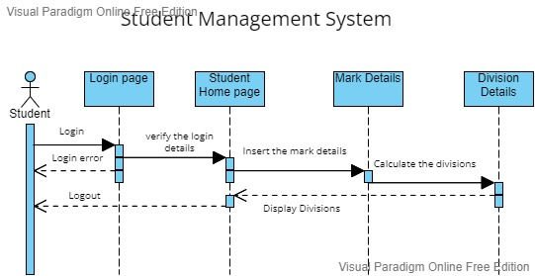

Proposed user Interface design
<Document the various interfaces available to the user through this story and module>

Database design changes
<Provide the logical design of the base data structures used to store the data. E.g Like tables, and views or entities and relationships>

Refactoring related changes
<Mention details of code re-factoring requirements; objective and scope of re-factoring and Changes to be done >

Construction strategy and re-use
< Mention about automated code development (using code-generator) or manual coding. Also identify make/buy/reuse components involved, if any >

Details of Alternative Design Approach
<Details of the alternative approach to resolve the maintenance request>

Other Technical changes

Automation tasks
<if the story is about automation (of test cases or some POC etc.), mention the details here>

CI / Build relates tasks
<If the story requirements are about implementation of continuous integration or build, update the details to be done here>

Non-functional related changes
<Non-functional requirements related to response time, System load or Network load>

Additional details

Open Questions / clarifications / Assumptions
<Mention the details of any open technical questions/clarifications or assumptions made, pertaining to story >

Additional notes to technical team
<provide details if any>

References
< Provide reference details if any >

